**Business Requirements Specification**

**for the**

**Nomination and Matching Procedures**

**In Gas Transmission Systems (NOM BRS)**

**Version 0 Revision 17 – 2016-06-22**

**Log of changes**

|  |  |  |
| --- | --- | --- |
| **Change** | **Date of change** | **Issuer of change** |
| References to NC BAL updated based on structure of Regulation after comitology | 1 July 2014 | ENTSOG |
| Addition of a table reflecting reference documents and status of these | 1 July 2014 | ENTSOG |
| Addition of authorisation process for single sided nominations in point 3.3.3.3  Addition of optional time stamp to the forward nomination flow in point 3.5.3  Minor clarifications:   * Clarification on legal scope in lines 116-118 * Clarification on content of nomination in lines 210-212 * Clarification on submission of interruption notice in lines 480-482 | 27 May 2015 | ENTSOG |
| Inserted clarification of the Common Data Exchange Solutions  Inserted the Common Data Exchange Solution Table and further explanation | 12 April 2016 | ENTSOG |
| Updated clarification of Common Data Exchange Solutions  Updated the Common Data Exchange Solution Table and further explanation | 22 June 2016 | ENTSOG |

**Table of contents**

1 Objective 6

2 Scope 6

3 Business requirements 8

3.1 Nomination requirements 8

3.2 List of actors 9

*3.2.1* *Registered Network User* 9

*3.2.2* *Transmission System Operator* 9

3.3 Use case detail 10

*3.3.1* *Provide market specific information* 10

*3.3.2* *Submit nominations* 10

*3.3.3* *Process nomination requests received* 11

*3.3.3.1* *Process single sided nominations* 11

*3.3.3.2* *Process nominations* 11

*3.3.3.3* *Authorisation process for single sided nominations* 12

*3.3.4* *Match nominations* 13

*3.3.5* *Confirm nominations* 13

3.4 Where the registered Network User submits single sided, he may also inform the counterparty of the results.Information flow definition 14

*3.4.1* *Nomination Sequence flow* 14

*3.4.2* *Nomination Workflow* 17

*3.4.2.1* *Pre-nomination process workflow* 17

*3.4.2.2* *Nomination process workflow* 18

*3.4.3* *General Acknowledgement process* 21

*3.4.3.1* *Business process definition* 21

*3.4.3.2* *Technical acknowledgment* 22

*3.4.3.3* *Application acknowledgment* 22

3.5 Information model requirements 24

*3.5.1* *Nomination information flow* 24

*3.5.2* *Interruption information flow* 25

*3.5.3* *Forward nomination flow* 27

*3.5.4* *Matching submission information flow* 28

*3.5.5* *Matching results information model* 30

*3.5.6* *Registered Network User confirmation information flow* 31

3.6 Definitions of the attributes used in all the models 33

3.7 Requirements per process 36

*3.7.1* *Nomination process* 36

*3.7.2* *Forward nomination process* 36

*3.7.3* *Interruption process* 37

*3.7.4* *Matching process* 37

*3.7.5* *Matching Transmission System Operator confirmation process* 38

*3.7.6* *Registered Network User confirmation process* 38

4 Common Data Exchange Solution Table 39

This section describes the common data exchange solution for each data exchange identified in this process. 39

5 Reference documents 41

**Table of figures**

Figure 1: overview of the Nomination process use case 8

Figure 2: Information flow sequence 14

Figure 3: Pre-nomination workflow 17

Figure 4: Nomination workflow 18

Figure 5: Nomination process workflow 20

Figure 6: Acknowledgement process 22

Figure 7: Nomination information flow 24

Figure 8: Interruption information flow 25

Figure 9: Forward nomination flow 27

Figure 10: Matching information flow 28

Figure 11: Nomination confirmation information flow 30

Figure 12: Registered Network User nomination confirmation information flow 31

Figure 13: Nomination process information requirements 36

Figure 14: Forwarded nomination information requirements 36

Figure 15: Interruption process information requirements 37

Figure 16: Matching process information requirements 37

Figure 17: TSO confirmation process information requirements 38

Figure 18: Registered Network User confirmation information requirements 38

# Objective

Commission Regulation (EU) No 312/2014 of 26 March 2014 establishing a Network Code on Gas Balancing of Transmission Networks (hereinafter ‘NC BAL’) sets forth provisions in respect to gas balancing regimes within the borders of the European Union with the aim to facilitate gas trading across Balancing Zones toward greater market integration.

It defines gas balancing rules, including network-related rules on nominations procedure, on imbalance charges and on operational balancing as required by Article 8(6) (j) of Regulation (EC) No 715/2009.

Its aim is to harmonise gas balancing arrangements to support the completion and functioning of the European internal gas market, the security of supply and appropriate access to the relevant information, in order to facilitate trade, including cross-border trade, to move forward towards greater market integration.

Commission Regulation (EU) No 984/2013 of 14 October 2013 establishing a Network Code on Capacity Allocation Mechanisms in Gas Transmission Systems (hereinafter ‘NC CAM’) defines how adjacent Transmission System Operators cooperate in order to facilitate capacity sales, taking into consideration general commercial as well as technical rules related to capacity allocation mechanisms. The Congestion Management Principles (CMP) guidelines provide rules in respect to contractual congestion in gas transmission networks.

This document defines the business requirements that are necessary for a harmonised software implementation of the information exchanges necessary to satisfy the processes defined in the above mentioned Network Codes in addition to the future Network Code on Interoperability and Data Exchange Rules (hereinafter ‘NC INT’).

# Scope

This document outlines the external business requirements that are necessary in order to ensure a harmonised transmission of information between parties participating in the nomination and matching environment. It is intended for use by parties involved in such an implementation. In particular, it forms a specification to enable EASEE-gas to produce documentation that can be approved and published.

This Business Requirements Specification (BRS) covers the requirements for the harmonised implementation of nomination and matching process exchanges.

This Business Requirements Specification (BRS) is targeted towards business-to-business application interfaces. However, it may be equally put into place in a more user-orientated fashion through a web-based service.

This document does not define a governance process for attribute definitions or other requirements. Such a process will need to be determined and defined elsewhere.

The requirements set out in this document are subject to change if there is any change in the obligations on transmission system operators.

The Business Requirements Specification does not describe the process for determining the identification of which capacity is to be interrupted.

In the diagrams the notions of initiating and matching system operator appear, these roles may be provided by an intermediary where there is agreement between the transmission system operators.

For the avoidance of doubt, this document provides no formal obligations on TSOs and relevant NRAs with regards to how they are going to implement Art.19 (7) of Commission Regulation (EU) No 984/2013 in their national systems.

This document, for readability purposes, uses the single sided nomination process as systematically coming from the Initiating System Operator. However it should be clearly understood that a single sided nomination can be received by one or the other Transmission System Operators as bilaterally agreed by them. The receiver of the single sided nomination is independent from the initiating or matching role being played. If the Transmission System Operators agree then network users can decide themselves which Transmission System Operator will receive a single-sided nomination.

Note: The information requirements specify that multiple connection points are possible within an information flow. However it has been left to each Transmission System Operator to determine whether or not in an information flow it will be permitted to provide only one connection point or multiple connection points.

It should also be noted that all timings mentioned in the document are the maximum possible. All actions, however, should be taken as soon as reasonably possible.

For the submission of singles-sided nominations, the transmission system operators active at a respective connection point shall agree and make public to which of them single-sided nominations shall be submitted.

# Business requirements

This section describes in detail the business requirements that the information flows are intended to satisfy.

## Nomination requirements

This section outlines the overall business process behaviour of the system without going into the detailed internal workings of each entity. It defines the external requirements of the business process: the relationships between the entities concerned.

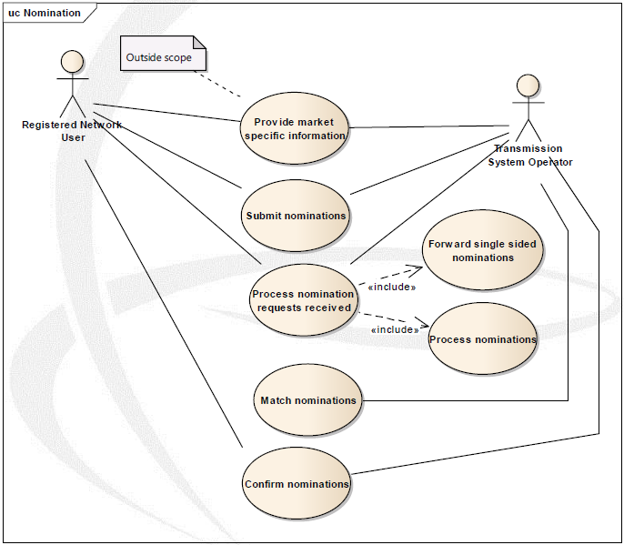

Figure 1: overview of the Nomination process use case

## List of actors

### *Registered Network User*

A network user that has acceded to and is compliant with all applicable legal and contractual requirements that enable him/her to book and use capacity on the relevant Transmission System Operator’s network under a capacity contract.

A Registered Network User in the context of this document has obtained a right to nominate and is understood in NC BAL as a Network User.

### *Transmission System Operator*

A natural or legal person who carries out the function of transmission and is responsible for operating, ensuring the maintenance of, and, if necessary, developing the transmission system in a given area, and, where applicable, its interconnections with other systems. It is also responsible for ensuring the long term ability of the system to meet reasonable demands for the transportation of gas.

At each connection point a Transmission System Operator may have specific roles in different contexts:

1. In the context of double-sided nominations in the interface with the Registered Network User:

* That of a Transmission System Operator who receives all nominations submitted by the Registered Network Users registered in the system operator’s area.

2. In the context of single sided nominations in the interface with the Registered Network User:

* That of the active Transmission System Operator who receives the single sided nominations submitted by a Registered Network User on behalf of itself and on behalf of the counter party Registered Network User of the adjacent Transmission System Operator to whom the active Transmission System Operator forwards the single sided nominations;
* That of the passive Transmission System Operator who is adjacent to the active Transmission System Operator and receives the single sided nominations forwarded by the active Transmission System Operator.

3. In the context of the matching process between Transmission System Operators

* That of an Initiating Transmission System Operator who is the Transmission System Operator that initiates the matching process by sending all necessary data to the Matching Transmission System Operator;
* That of a Matching Transmission System Operator who is the Transmission System Operator that performs the matching process and who sends the results to the Initiating Transmission System Operator.

## Use case detail

### *Provide market specific information*

This use case enables the provision of market specific information related to the Registered Network User to the Transmission System Operator. It is outside the scope of this Business Requirement Specification and is only provided for information.

This enables the establishment of the business rules and obligations for the use of single sided and double sided nominations between the Transmission System Operator and the Registered Network User.

### *Submit nominations*

This use case enables a Registered Network User to provide nominations for processing to a Transmission System Operator. A nomination may be submitted by only the Registered Network User at the side of the active Transmission System Operator on behalf of both parties (known as a single sided nomination) or by each Registered Network User on each side of the connection point (known as a double sided nomination).

A single sided nomination means that there is no corresponding nomination transmitted by the counter party Registered Network User to its Transmission System Operator. The active Transmission System Operator will forward the single sided nominations to the adjacent passive Transmission System Operator.

Both Transmission System Operators will agree bilaterally on who will be the active Transmission System Operator that receives the single sided nominations from his Registered Network Users. In principle, the Transmission System Operator that requires the nomination information more urgently due to market processes should be foreseen as active Transmission System Operator. However, if the involved Transmission System Operators agree, the concerned Registered Network Users can decide themselves which of the Transmission System Operators will receive the single sided nominations.

A double sided nomination means that both Registered Network Users must submit nominations independently to their respective Transmission System Operators on each side of the connection point.

A nomination request made by a Registered Network User to the active Transmission System Operator may contain a mix of both single sided and double sided nominations. Each individual nomination within a nomination request refers to a specific account pair, a specific connection point and a flow direction.

There is no distinction made in the nomination request between bundled and unbundled capacity or between firm and interruptible capacity. The nomination request on a given connection point shall contain uniquely the total nominated quantity, the flow direction and the counterpart. The Transmission System Operators at a connection point may decide to allow Registered Network Users to submit nomination requests on both directions of the gas flow or to submit the net nomination request.

### *Process nomination requests received*

This use case enables the Transmission System Operator receiving a nomination request to validate its content. This process will be detailed in the use cases “process single sided nominations” and “process nominations” described below.

The Transmission System Operator always acknowledges receipt of the nominations from the Registered Network User and the forwarded nominations from the Transmission System Operator that received a single sided nomination. The acknowledgement may be either positive or negative.

#### *Process single sided nominations*

For the purposes of clarity and ease of description the process for single sided nominations described in this document shows cases in which the active Transmission System Operator is always the Initiating Transmission System Operator and the passive Transmission System Operator is always the Matching Transmission System Operator. In practice, this combination of roles of the Transmission System Operators at a connection point is not a requirement. Depending on the agreement of the involved Transmission System Operators, single sided nominations could be submitted to both, the Initiating Transmission System Operator or the Matching Transmission System Operator.

All single sided nominations shall be passed by the active Transmission System Operator to the passive Transmission System Operator for local processing. Unless agreed otherwise by the involved Transmission System Operators, this shall be done as soon as technically possible and feasible but no later than 15 minutes after the (re)-nomination deadline(s). If required by the passive Transmission System Operator, the forwarded nomination message shall additionally contain for each received single sided nomination the point of time at which the original nomination message was technically received by the active Transmission System Operator.

A single sided nomination shall only be forwarded to the passive Transmission System Operator once the syntactical and semantic content of the submitted nomination is coherent.

It should be noted that within this process, the passive Transmission System Operator has to process all the single sided nominations that have been received from the active Transmission System Operator as if it would be a nomination sent by his own Registered Network User, to ensure that the validation rules are respected.

The forwarded nominations shall be transmitted on a per connection point basis.

#### *Process nominations*

All double sided and single sided nominations are handled together on a connection point, account pair and on a flow direction basis.

Standard processing is then carried out on each nomination to ensure that it respects all validation rules as well as ensuring that it remains within the nomination possibilities allowed for the Registered Network User, taking into account the time required for the forwarding in case of single sided nominations.

When necessary the Transmission System Operator provides interruption notifications to the Registered Network User. Such notifications are for information and are only submitted once per nomination period.

Once processing has been completed the Initiating Transmission System Operator transmits to the Matching Transmission System Operator the nominations as processed as well as the nominations as received if agreed bilaterally by the Transmission System Operators.

#### *Authorisation process for single sided nominations*

For the use of single sided nominations, the passive Transmission System Operator needs to establish a process that enables the counter party Registered Network User to authorise the Registered Network User in the system of the active Transmission System Operator to submit single sided nominations on its behalf to the active Transmission System Operator. Such an authorisation could e.g. be conducted via a website interface, an addendum to the transport contract, an Edig@s message, etc. The passive Transmission System Operator shall check whether for all forwarded single sided nominations a valid authorisation from the concerned counter party Registered Network User to the nominating Registered Network User is in place.

The data exchange solution for this data exchange is to be negotiated between the transmission system operator and the registered network user. In case an electronic message is used, the Edig@s format is recommended and is shown below:

|  |  |  |  |  |
| --- | --- | --- | --- | --- |
| **Information Flow** | **From Role** | **To Role** | **Confidentiality Level** | **Data Exchange Solution** |
| Nomination Authorisation | Registered Network User | Transmission System Operator | Private | Recommendation - Document Based |

The authorisation from the counter party Registered Network User to the passive Transmission System Operator shall contain at least the following information:

* The account or portfolio code of the Registered Network User that is authorising another Registered Network User to submit single sided nominations on its behalf;
* The account or portfolio code of the Registered Network User that is authorised to submit single sided nominations on its behalf;
* The connection points for which the authorisation is valid;
* The validity period (start and end date) of the authorisation.

The above-described authorisation process is not obligatory for cases in which a single sided nomination is submitted on behalf of one legal entity active in both networks, if the involved Transmission System Operators conclude a bilateral agreement allowing them to check the identities of nominating Registered Network Users. In such a case, the involved transmission system operator can decide not to require an authorisation from the network user in order to process single sided nominations. If in such a case the Registered Network User that submitted a single sided nomination to the active Transmission System Operator is also submitting a corresponding counter nomination to the passive Transmission System Operator, the nominations shall be processed as double sided nominations, unless specified otherwise by the Transmission System Operators.

If a passive Registered Network User submits a nomination to the passive Transmission System Operator affecting an account or portfolio code of the active Registered Network User for a period for which a valid authorisation between the two Registered Network Users is in place, the nomination shall be processed as double sided and the respective authorisation shall be deactivated for the respective gas day, unless specified otherwise by the Transmission System Operators.

### *Match nominations*

This use case enables the Matching Transmission System Operator to match the processed results from both sides and to determine the quantities that are to be confirmed.

Once the matching has been finalised the confirmed nominations and the processed quantities established by the Matching Transmission System Operator are transmitted to the Initiating Transmission System Operator. If agreed between Transmission System Operators the double sided original nominations received by the Matching Transmission System Operator may also be transmitted.

### *Confirm nominations*

This use case enables a Transmission System Operator to confirm to the Registered Network User the results of the submitted nomination requests.

In the case of single sided nominations as well as double sided nominations each Transmission System Operator shall provide the confirmed nominations to their respective Registered Network User.

## Where the registered Network User submits single sided, he may also inform the counterparty of the results.Information flow definition

### *Nomination Sequence flow*

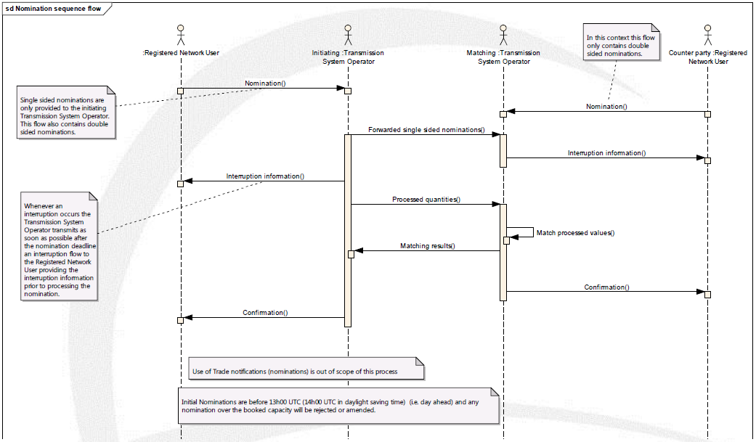

Figure 2: Information flow sequence

The operational sequence is broken down into 5 mandatory information flows and one optional flow. A sixth flow simply identifies for clarification the point where matching takes place.

The five mandatory flows are:

1. The transmission of nomination information between the Registered Network User and the Transmission System Operator. In case of double sided nominations, the information shall be submitted to the Initiating Transmission System Operator and to the Matching Transmission System Operator by the respective Registered Network User(s). In case of single sided nominations, the information shall be submitted to the active Transmission System Operator (in this example being the Initiating Transmission System Operator).

The common data exchange solution for the data exchange for double sided nominations is shown below:

|  |  |  |  |  |
| --- | --- | --- | --- | --- |
| **Information Flow** | **From Role** | **To Role** | **Confidentiality Level** | **Common Data Exchange Solution** |
| Nomination | Registered Network User | (Initiating) Transmission System Operator | Private | Document Based |
| Nomination | Registered Network User | (Matching) Transmission System Operator | Private | Document Based |

1. The transmission of single sided nomination information from the active Transmission System Operator to the passive Transmission System Operator (in this example from the Initiating Transmission System Operator to the Matching Transmission System Operator) in accordance with point 3.3.3.1 all the single sided nominations that have been received.

The common data exchange solution for this data exchange is shown below:

|  |  |  |  |  |
| --- | --- | --- | --- | --- |
| **Information Flow** | **From Role** | **To Role** | **Confidentiality Level** | **Common Data Exchange Solution** |
| Forward Single Sided Nomination | (Active) Transmission System Operator | (Passive) Transmission System Operator | Private | Document Based |

1. The transmission of matching information between the Initiating Transmission System Operator and the Matching Transmission System Operator. This transmission occurs within 45 minutes after the nomination deadline and contains all the nominations processed by the Initiating Transmission System Operator and optionally the nomination.

The common data exchange solution for this data exchange is shown below:

|  |  |  |  |  |
| --- | --- | --- | --- | --- |
| **Information Flow** | **From Role** | **To Role** | **Confidentiality Level** | **Common Data Exchange Solution** |
| Processed Quantities | (Initiating) Transmission System Operator | (Matching) Transmission System Operator | Private | Document Based |

1. The transmission of the matching results between the Matching Transmission System Operator and the Initiating Transmission System Operator. This transmission occurs within 90 minutes after the nomination deadline and contains at least all the nominations where the processed information has been matched and that are confirmed. It also contains the processed results on the Matching Transmission System Operator side and optionally the nomination.

The common data exchange solution for this data exchange is shown below:

|  |  |  |  |  |
| --- | --- | --- | --- | --- |
| **Information Flow** | **From Role** | **To Role** | **Confidentiality Level** | **Common Data Exchange Solution** |
| Matching Results | (Matching) Transmission System Operator | (Initiating) Transmission System Operator | Private | Document Based |

1. The transmission of the confirmation between the Transmission System Operator and the Registered Network Users. This transmission occurs within two hours after the nomination deadline and contains the results of their nominations.

The common data exchange solution for this data exchange is shown below:

|  |  |  |  |  |
| --- | --- | --- | --- | --- |
| **Information Flow** | **From Role** | **To Role** | **Confidentiality Level** | **Common Data Exchange Solution** |
| Confirmation Notice | (Initiating) Transmission System Operators | Registered Network Users | Private | Document Based |
| Confirmation Notice | (Matching) Transmission System Operators | Registered Network Users | Private | Document Based |

A sixth information flow, interruption information, only occurs in the case where a Transmission System Operator has introduced an interruption to the Registered Network User nomination. In this case the Transmission System Operator informs the Registered Network User of the interruptions that have affected the nomination. This information is basically provided for information since processing of the nomination may not yet be completed. It must occur within the 45 minutes after the nomination deadline.

The common data exchange solution for this data exchange is shown below:

|  |  |  |  |  |
| --- | --- | --- | --- | --- |
| **Information Flow** | **From Role** | **To Role** | **Confidentiality Level** | **Common Data Exchange Solution** |
| Interruption Information | (Initiating) Transmission System Operator | Registered Network User | Private | Document Based |
| Interruption Information | (Matching) Transmission System Operator | Registered Network User | Private | Document Based |

### *Nomination Workflow*

#### *Pre-nomination process workflow*

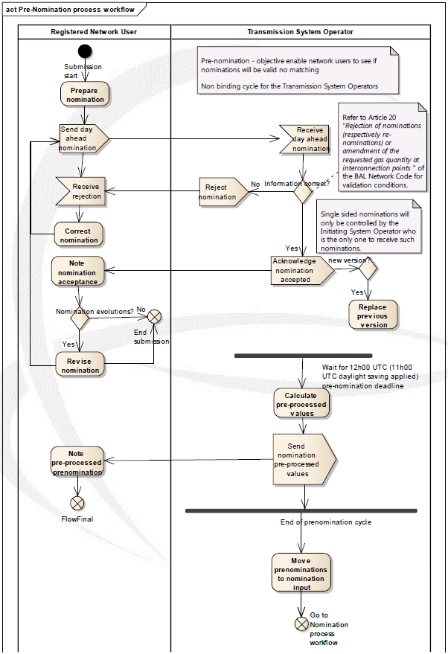

Figure 3: Pre-nomination workflow

The pre-nomination process is to enable a Registered Network User to verify if the nominations submitted are valid in the environment of the receiving Transmission System Operator. The Registered Network User receives a response based on the pre-processed values. There is no matching carried out nor is the information passed to the Matching Transmission System Operator.

This step is not a binding possibility for a Transmission System Operator and may be not permitted if not agreed by both Transmission System Operators. If the step is permitted then the Registered Network User may decide to use it or not.

#### *Nomination process workflow*

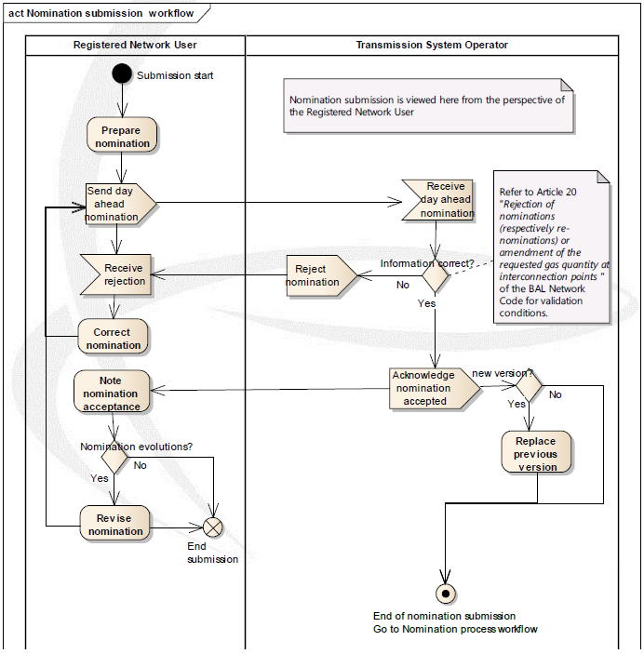

Figure 4: Nomination workflow

Nomination submissions are carried out as depicted in figure 4. The Registered Network User submits all nominations to the local Transmission System Operator.

In the case of single sided nominations only the Registered Network User whose Transmission System Operator acts as the active Transmission System Operator submits the single sided nominations.

Once the nomination submission has terminated and the nomination deadline has been met the matching process as depicted in figure 5 is carried out.

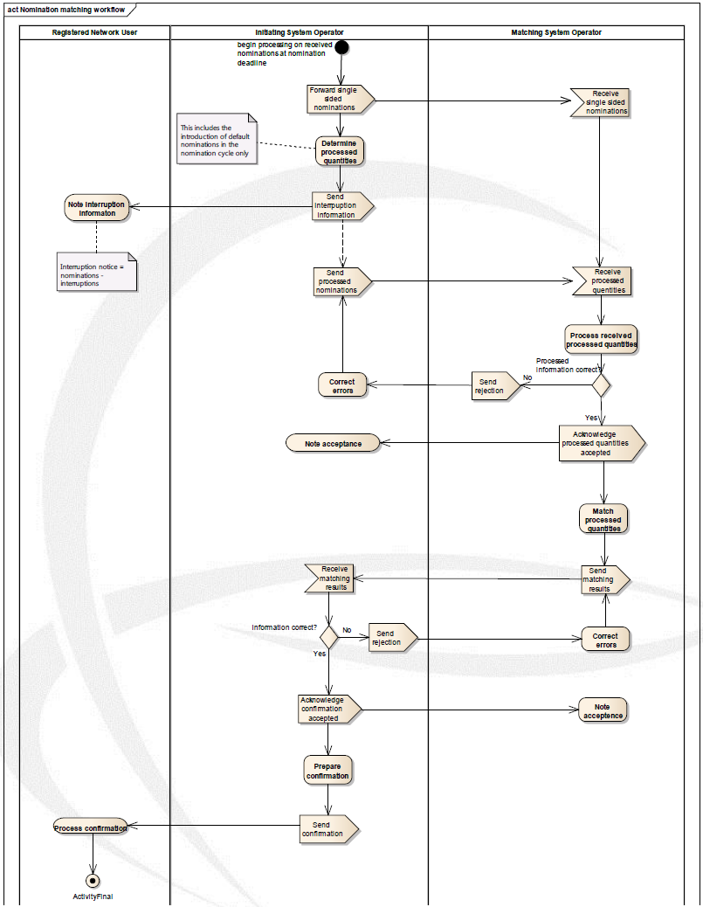

Figure 5: Nomination process workflow

The active Transmission System Operator then transmits all single sided nominations to the passive Transmission System Operator within 15 minutes after the nomination deadline in order to facilitate processing by the passive Transmission System Operator.

Once the nominations have been accepted, they are processed by the Transmission System Operators in order to ensure that they comply with local market rules.

If either Transmission System Operator has to carry out an interruption this information is provided to the Registered Network User for information.

Once all nominations have been processed, the Initiating Transmission System Operator transmits the processed results and optionally the nominations to the Matching Transmission System Operator.

All the processed quantities received from the Initiating Transmission System Operator are matched with all the processed quantities established by the Matching Transmission System Operator.

Any differences in the matching process have a basic rule applied (in general the lesser values rule). The final confirmed quantities are then transmitted by the Matching Transmission System Operator to the Initiating Transmission System Operator. This includes the quantities processed by the Matching Transmission System Operator and optionally all the nominations received.

The Initiating and Matching Transmission System Operators then confirm to their respective Registered Network Users the results of the matching process.

### *General Acknowledgement process*

#### *Business process definition*

The acknowledgment business process is generic and can be used in all the energy market business processes at two levels:

* System level: To detect syntax errors (parsing errors, etc.);
* Application level: To detect semantic errors (invalid data, wrong process, etc.).

If there is a problem encountered at the first level, then a technical acknowledgement may be sent to inform the originator of the problem.

If errors are encountered at the second level or if the application can successfully process the information, then an application acknowledgement may be sent to inform the issuer of the situation.

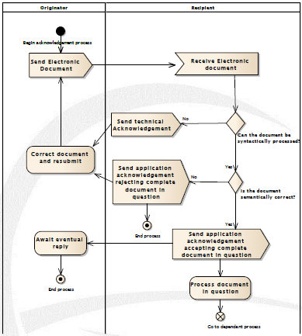

Figure 6: Acknowledgement process

#### *Technical acknowledgment*

A technical acknowledgement occurs when an electronic document is received that cannot be correctly processed for submission to the application. Such an error could occur for example whenever the XML parser cannot correctly parse the incoming document. Other instances could be the incapacity to correctly identify the issuer of the document in relation to the process requested.

In such a case a technical acknowledgement can be sent to the document issuer providing the information that the XML document in question cannot be correctly processed by the system.

#### *Application acknowledgment*

Within each business process of the gas market, business rules are to be defined stating whether or not an application acknowledgment is to be sent upon reception of an electronic document.

In particular, where the originator is in the role of a Transmission System Operator and the recipient is in a “market participant” type role, all electronic documents sent by entities in the role of a Transmission System Operator shall be considered as received and correct, and the acknowledgement process is not required unless an acknowledgment document is required for a specific purpose.

Otherwise, upon reception, checks are to be carried out at the application level to assess that the received document can be correctly processed by the application. The issuer is informed that:

* Its document, that is stated as valid after this verification, is ready to be processed by the reception of an acknowledgement document accepting the complete document in question;
* Its document is rejected for processing by the reception of an acknowledgement document rejecting the complete document in question with details on the level of errors.

## Information model requirements

The following information requirements have been identified as the essential business information that needs to be catered for in the relevant information exchanges. They are outlined in the paragraphs below.

### *Nomination information flow*

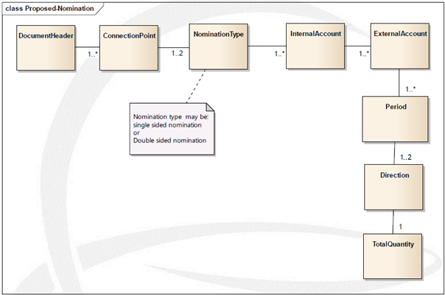

Figure 7: Nomination information flow

The nomination information flow is broken down into the following classes of information:

1. The header that provides all the information concerning the identification of the nomination including the gas day.
2. The Connection Point that identifies the connection point identification. Multiple connection points are permitted per nomination.
3. The Nomination Type indicating whether the nomination for the connection point is single sided or double sided.
4. The Internal Account that identifies the account of the submitting Registered Network User that is managed by the Transmission System Operator receiving the nomination (Article 16.3 of BAL NC). There may be multiple internal accounts for a given connection point. An internal account must have the identification of the Transmission System Operator that provides the code.
5. The External Account that identifies the account of the counterpart Registered Network User that is managed by the counterpart System Operator (Article 13(4) of NC BAL). There may be many external accounts for a given internal account. An external account must have the identification of the Transmission System Operator that provides the code.
6. The Period that identifies the time period for which the information provided relates (Article 13(5) of NC BAL). A time period may only relate to a gas day in the case of standard nominations (Article 13(6) of NC BAL). The management of any other period is outside the scope of this specification. A time period may be expressed as a complete gas day or as a number of parts of the gas day (e.g. 24 hours).
7. The Direction that identifies whether the nomination provided is an input or an output to the area of the Transmission System Operator.
8. The Total Quantity being nominated.

Note: for a given connection point the value of the internal account combined with the value of the external account shall only appear once per flow direction. As defined in 3.3.2, the Transmission System Operators at a connection point may decide to allow Registered Network Users to submit nomination requests on both directions of the gas flow or to submit the net nomination requests.

### *Interruption information flow*

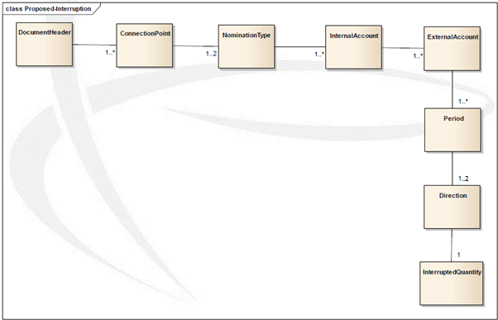

Figure 8: Interruption information flow

The optional interruption information flow is only provided if an interruption occurs against the Registered Network Users nomination. It is transmitted as soon as possible after the interruption is identified by the interrupting transmission system operator to its respective registered network user, irrespective of whether a single sided or double sided nomination was initially submitted. It is only transmitted once in the nomination cycle. It can occur that it does not represent the final processed value that is submitted to a Matching Transmission System Operator.

The interruption information flow is broken down into the following classes of information:

1. The header that provides all the information concerning the identification of the interruption including the gas day.
2. The Connection Point that identifies the connection point. Multiple connection points are permitted per interruption.
3. The Nomination Type indicating whether the interruption for the connection point affects a single sided or double sided nomination.
4. The Internal Account that identifies the account of the submitting Registered Network User that is managed by the Transmission System Operator that has applied the interruption. There may be multiple internal accounts for a given connection point. An internal account must have the identification of the Transmission System Operator that provides the code.
5. The External Account that identifies the account of the counterpart Registered Network User that is managed by the counterpart Transmission System Operator. There may be many external accounts for a given internal account. An external account must have the identification of the Transmission System Operator that provides the code.
6. The Period that identifies the time period that has been specified in the nomination.
7. The Direction that identifies whether the nomination provided is an input or an output to the area of the Transmission System Operator.
8. The Quantity which reflects the value expressed in the nomination but reduced in compliance with the interruption.
9. Interruption type (optional) providing optional information by the Transmission System Operator on the type and the reasoning of an interruption.

### *Forward nomination flow*



Figure 9: Forward nomination flow

In the case of a single sided nomination, it is necessary that this information is forwarded to the passive Transmission System Operator by the active Transmission System Operator, in order to enable the information to be processed. The information flow is broken down into the following classes of information:

1. The Header that provides all the information concerning the identification of the single sided nomination including the gas day.
2. The Connection Point that identifies the connection point identification. If agreed by the involved Transmission System Operators, multiple connection points are permitted per nomination request.
3. The Internal Account that identifies the account of the submitting Registered Network User that is managed by the forwarding Transmission System Operator. There may be multiple internal accounts for a given connection point. An internal account must have the identification of the Transmission System Operator that provides the code.
4. The External Account that identifies the account of the counterpart Registered Network User that is managed by the counterpart System Operator. There may be many external accounts for a given internal account. An external account must have the identification of the Transmission System Operator that provides the code.
5. If applicable, the time stamp that identifies the point of time at which the initial single sided nomination was received by the active transmission system operator.
6. The Period that identifies the time period for which the information provided relates. A time period may only relate to a gas day in the case of standard nominations. The management of any other period is outside the scope of this specification. A time period may be expressed as a complete gas day or as a number of parts of the gas day (e.g. 24 hours).
7. The Direction that identifies whether the nomination provided is an input or an output to the area of the Transmission System Operator forwarding the nomination.
8. The Total nominated Quantity being nominated.

### *Matching submission information flow*

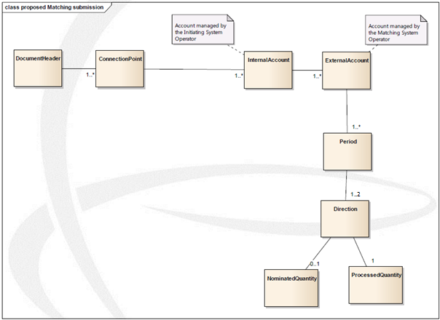

Figure 10: Matching information flow

A matching information flow contains the processed values of nominations received by the Initiating Transmission System Operator. It may contain the quantity nominated by the Registered Network User.

The matching information flow is broken down into the following classes of information:

1. The Header that provides all the information concerning the identification of the matching flow including the gas day.
2. The Connection Point that identifies the connection point. Multiple connection points are permitted per matching information flow.
3. The Internal Account that identifies the account of the submitting Registered Network User that is managed by the Initiating Transmission System Operator. There may be multiple internal accounts for a given connection point. An internal account must have the identification of the Transmission System Operator that provides the code.
4. The External Account that identifies the account of the counterpart Registered Network User that is managed by the Matching Transmission System Operator. There may be many external accounts for a given internal account. An external account must have the identification of the Transmission System Operator that provides the code.
5. The Period that identifies the time period as identified in the nomination flow.
6. The Direction that identifies whether the nomination provided is an input or an output to the area of the Initiating Transmission System Operator.
7. The Nominated Quantity represents the quantity nominated by the Registered Network User and may optionally be provided.
8. The Processed Quantity which represents the quantity as processed by the Initiating Transmission System Operator.

### *Matching results information model*

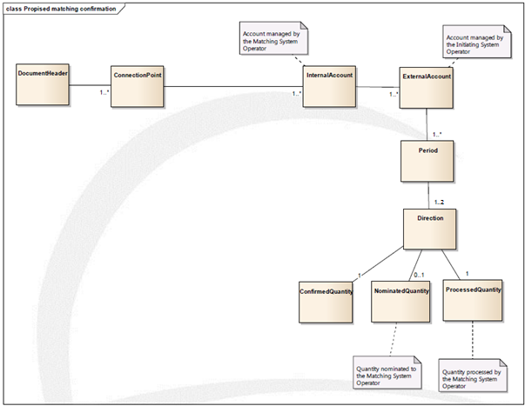

Figure 11: Nomination confirmation information flow

When the Matching Transmission System Operator terminates the matching process the matching results are transmitted to the Initiating Transmission System Operator.

The matching results information flow is broken down into the following classes of information:

1. The Header that provides all the information concerning the identification of the matching results flow including the gas day.
2. The Connection Point that identifies the connection point. Multiple connection points are permitted per matching results information flow.
3. The Internal Account that identifies the account of the submitting Registered Network User that is managed by the Matching Transmission System Operator. There may be multiple internal accounts for a given connection point. An internal account must have the identification of the Transmission System Operator that provides the code.
4. The External Account that identifies the account of the counterpart Registered Network User that is managed by the Initiating Transmission System Operator. There may be many external accounts for a given internal account. An external account must have the identification of the Transmission System Operator that provides the code.
5. The Period that identifies the time period as identified in the nomination flow.
6. The Direction that identifies whether the nomination provided is an input or an output to the area of the Matching Transmission System Operator.
7. The Confirmed Quantity for the nomination.
8. The Nominated Quantity that has been received by the Matching Transmission System Operator may optionally be provided.
9. The Processed Quantity that has been carried out by the Matching Transmission System Operator.

### *Registered Network User confirmation information flow*

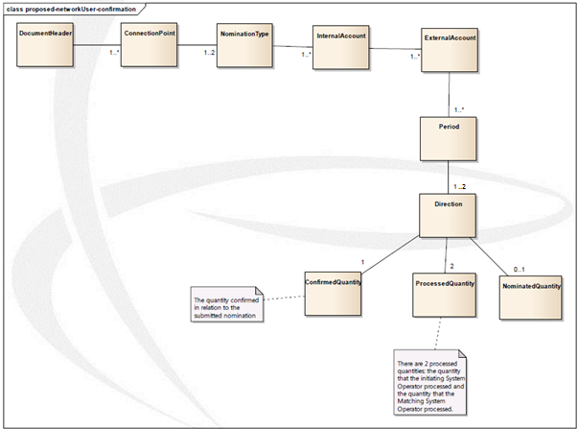

Figure 12: Registered Network User nomination confirmation information flow

This information flow is provided by the Transmission System Operators to the Registered Network Users to confirm the quantities that will be taken into consideration in the Registered Network User nominations.

The nomination confirmation information flow is broken down into the following classes of information:

1. The Header that provides all the information concerning the identification of the nomination confirmation flow and relates it to the nomination including the gas day.
2. The Connection Point that identifies the connection point. Multiple connection points are permitted per nomination confirmation information flow.
3. The Nomination Type indicating whether the information concerns a single sided or double sided nomination
4. The Internal Account that identifies the account of the Registered Network User to whom the confirmation is being sent that is managed by the Transmission System Operator transmitting the nomination confirmation. There may be multiple internal accounts for a given connection point. An internal account must have the identification of the Transmission System Operator that provides the code.
5. The External Account that identifies the account of the counterpart Registered Network User that is managed by the counterpart Transmission System Operator. There may be many external accounts for a given internal account. An external account must have the identification of the Transmission System Operator that provides the code.
6. The Period that identifies the time period as identified in the nomination flow.
7. The Direction that identifies whether the nomination provided is an input to the System Operator area or whether it is an output.
8. The Confirmed Quantity in relation to the quantity nominated. Each Transmission System Operator shall provide the confirmed nominations to its submitting Registered Network User. Where the Registered Network User submits single sided nominations, he may also inform the counter party of the results.
9. The Processed Quantities that have been calculated by both Transmission System Operators.
10. The Nominated Quantity that had been submitted by the counter party Registered Network User. This information is optionally provided if it has been provided by the relevant Transmission System Operator. If the Registered Network User had submitted a single sided nomination this information is not provided.

## Definitions of the attributes used in all the models

Definitions originating from the NC CAM, NC BAL and NC INT will be reviewed as soon as the document has been finalized.

|  |  |
| --- | --- |
| **Name** | **Description** |
| Common Data Exchange Solution | Means the type of data exchange to be made available by all TSOs as defined in the Network Code Interoperability and Data Exchange Rules. |
| Confidentiality Level | Means the level of confidentiality that is to be applied on the data in a given data exchange. The confidentiality level used in this process for all data is Private. Private means the data is only to be shared between the two parties. |
| Confirmed quantity | Means the quantity of gas confirmed by a TSO to be scheduled or rescheduled to flow on Gas Day D. At an Interconnection Point, the Confirmed Quantity(-ies) will take into account Processed Quantity(-ies) and the matching process used for comparing and aligning the requested gas quantity to be transported by Network Users at both sides of an Interconnection Point. |
| Direction | The indication of whether a gas flow is an input or an output in respect to the Transmission System Operator area where the information is being submitted.  In all messages exchanged between Transmission System Operators, each Transmission System Operator declares Input and Output in relation to their system (for instance: Input quantities sent from TSO1 to TSO2 will become Output quantities in the corresponding ICT system of TSO 2 and vice versa). |
| Double sided nomination | A nomination that is submitted by both Registered Network Users to their respective Transmission System Operators. |
| External Account | Network user’s counterparty identification or, if applicable, it’s balancing portfolio identification; (Article 13(4) of NC BAL). |
| Gas Day | Means the period from 5:00 to 5:00 UTC or, when daylight saving time is applied, from 4:00 to 4:00 UTC (origin: NC CAM). |
| Information Flow | Description of the function of a given data exchange. |
| Initiating Transmission System Operator | Means the transmission system operator initiating the matching process by sending necessary data to the Matching Transmission System Operator. |
| Interconnection point (also termed Connection Point) | Means a physical or virtual point connecting adjacent entry-exit systems or connecting an entry-exit system with an interconnector, in so far as these points are subject to booking procedures by network users (origin: NC CAM) |
| Internal Account | Network user identification or, if applicable, it’s balancing portfolio identification (Article 13(3) of NC BAL). |
| Matching Transmission System Operator | Means the Transmission System Operator performing the matching process and sending the result to the Initiating Transmission System Operator. |
| Network User’s Counterparty | Means the Network User who delivers gas to or receives gas from a Network User at an Interconnection Point. |
| Nominated quantity | means a quantity of gas nominated by a network user for exchange on an interconnection point with a network user for a gas day D. |
| Nomination request | Refers to a set of nominations submitted by a Registered Network User. |
| Nomination Type | An indication whether a nomination is single sided or double sided. |
| Period | Start time and end time of the gas flow for which the nomination or re-nomination is submitted. (A period concerns one gas day according to Article 13(5) of NC BAL). |
| Processed quantity | Means the quantity of gas that the TSO is scheduling for flow, which takes into account the Network User’s nomination (respectively re-nomination), contractual conditions and the capacity as defined under the relevant transport contract |
| Single sided nomination | A nomination that is submitted by a Registered Network user on behalf of both involved parties to only one Transmission System Operator.  A single sided nomination can be received by one or the other Transmission System Operators as bilaterally agreed by them. The receiver of the single-sided nomination is referred to as ‘active’ Transmission System Operator while the adjacent party is referred to as ‘passive’ Transmission System Operator. Whether a Transmission System Operator is active or passive in the process of handling single-sided nominations is independent from the initiating or matching role being played. If the Transmission System Operators agree then network users can decide themselves which Transmission System Operator will receive a single-sided nomination |
| Transmission System Operator | Also termed “TSO” and is defined in Article 2(4) of the Directive or the entity responsible for keeping the transmission network in balance in accordance with and to the extent defined under the applicable National Rules. |

## Requirements per process

### *Nomination process*

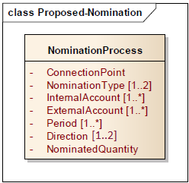

Figure 13: Nomination process information requirements

Note 1: wherever the indication [0..*] appears against an attribute this signifies that the attribute in question is optional. For example, the attribute “InternalAccount [0..*]” is not used in the case of ultimate users. The indication [1..*] means that at least one occurrence of the information must be present.

Note 2: The information outlined in the class diagram does not represent any structural constraints. It only represents the information requirements for a given information flow.

### *Forward nomination process*

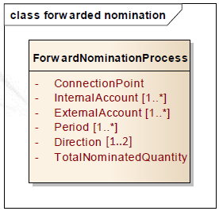

Figure 14: Forwarded nomination information requirements

### *Interruption process*

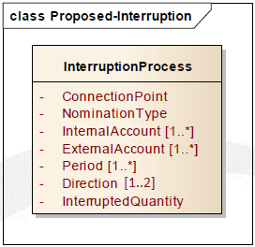

Figure 15: Interruption process information requirements

### *Matching process*

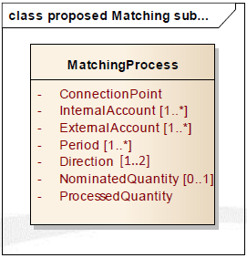

Figure 16: Matching process information requirements

### *Matching Transmission System Operator confirmation process*

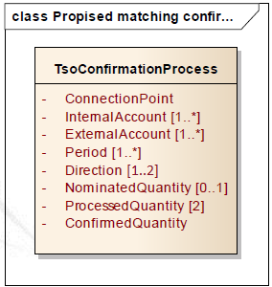

Figure 17: TSO confirmation process information requirements

### *Registered Network User confirmation process*

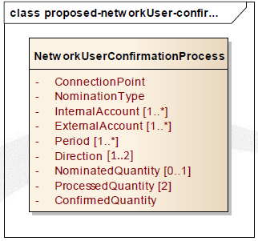

Figure 18: Registered Network User confirmation information requirements

# 

# Common Data Exchange Solution Table

# This section describes the common data exchange solution for each data exchange identified in this process.

|  |  |  |  |  |
| --- | --- | --- | --- | --- |
| **Information Flow** | **From Role** | **To Role** | **Confidentiality Level** | **Common Data Exchange Solution** |
| Nomination Authorisation* | Registered Network User | Transmission System Operator | Private | Recommendation - Document Based |
| Nomination | Registered Network User | (Initiating) Transmission System Operator | Private | Document Based |
| Nomination | Registered Network User | (Matching) Transmission System Operator | Private | Document Based |
| Forward Single Sided Nomination | (Active) Transmission System Operator | (Passive) Transmission System Operator | Private | Document Based |
| Processed Quantities | (Initiating) Transmission System Operator | (Matching) Transmission System Operator | Private | Document Based |
| Matching Results | (Matching) Transmission System Operator | (Initiating) Transmission System Operator | Private | Document Based |
| Confirmation Notice | (Initiating) Transmission System Operators | Registered Network Users | Private | Document Based |
| Confirmation Notice | (Matching) Transmission System Operators | Registered Network Users | Private | Document Based |
| Interruption Information | (Initiating) Transmission System Operator | Registered Network User | Private | Document Based |
| Interruption Information | (Matching) Transmission System Operator | Registered Network User | Private | Document Based |

# * The data exchange solution indicated with (*) is to be negotiated between the transmission system operator and the registered network user. In case an electronic message is used, the Edig@s format is recommended.

# Reference documents

|  |  |  |  |
| --- | --- | --- | --- |
| Document | Status | Date of last status change | Link |
| Commission Regulation (EU) No 984/2013 establishing a Network Code on Capacity Allocation Mechanisms in Gas Transmission Systems | In force | 14 October 2013 | [Link](http://www.entsog.eu/public/uploads/files/publications/CAM%20Network%20Code/2013/EC_131014_CAM%20NC_Regulation%20984-2013.pdf) |
| Commission regulation (EU) 312/2014 establishing a Network Code on Gas Balancing of Transmission Networks | In force | 26 March 2014 | [Link](http://www.entsog.eu/public/uploads/files/publications/Balancing/2013/BAL%20NC%20-%20Commission%20Regulation.pdf) |
| Network Code on Interoperability and Data Exchange | Publication in official Journal pending |  | [Link](http://www.entsog.eu/public/uploads/files/publications/INT%20Network%20Code/2013/ACERSubmission/INT0352_131218_Network%20Code_Network%20Code%20on%20Interoperability%20and%20Data%20Ex%20%20%20.pdf) |