Public Consultation

ENTSOG and EASEE-Gas carried out a joint Workshop on Data Exchange on 4 November 2018 in Brussels.
ENTSOG presented the new developments on the AS4 profile v3.6 based on input provided during a AS4 question & answer session carried out at the beginning of 2018.
EASEE-Gas presented the new version 6 of the format Edig@s and the new roles and processes which have been identified during the development of the Harmonized Role Model for gas.
We kindly ask you for your opinion regarding the development of the draft AS4 profile v3.6 and the proposed functionalities for Edig@s v6.
The links to the relevant documents are available next to the respective questions.

We kindly ask you to provide your answers via Survey Monkey https://www.surveymonkey.com/r/B5JCHTN

Questions

- Name and contact details
Name: Click or tap here to enter text.
Country:Click or tap here to enter text.
Email Address:Click or tap here to enter text.
Phone Number:Click or tap here to enter text.

- Your contribution
☐ can be published with your organisation's information
☐ can be published provided that your organisation remains anonymous

- Please indicate your role
☐ Network User
☐ National Regulatory Authority
☐ Transmission System Operator
☐ Stakeholder association
☐ Storage System Operator
☐ Market Area Manager
☐ LNG System Operator
☐ Other
Other (please specify: Click or tap here to enter text.

- Do you have AS4 in place?
☐ Yes
☐ No

ENTSOG AS4 Usage Profile
- Did you develop your AS4 system based on the ENTSOG usage profile?
Please find the AS4 usage profile documentation here:
AS4 Usage Profile v3.5
Comparison AS4 Usage Profile 2 vs 3.5
☐ Yes, based on version 3.5
☐ Yes, based on version 2
☐ No
Comments (optional) Click or tap here to enter text.

- Do you agree with the proposed changes in the new version of the ENTSOG AS4 usage profile v3.6?
AS4 Usage profile Rev 3.6 draft
AS4 Usage profile comparison v. 3.5 vs 3.6
Please note that the version 3.6 has not been approved yet. This is a draft version for consultation.
Please feel free to provide any feedback in the comment field.
☐ Yes
☐ No
Comments (optional) Click or tap here to enter text.

Current Edig@s usage
- For which processes are you using Edig@s?
Please have a look at the Edig@s website for detailed description of the message type and their usage for each process
https://www.edigas.org/version-5/
☐ Capacity Trading Process | ☐ Settlement Process
☐ Gas Trading Process | ☐ Balancing Process
☐ Nomination and Matching Process | ☐ Transparency process
☐ Facility Setting Process | ☐ General Service Process
☐ Market Balancing Process | ☐ REMIT Reporting Process
Comments (optional) Click or tap here to enter text.

- Which Edig@s version are you using
☐ Edig@s 5
☐ Edig@s 4
☐ No implementation of Edig@s
☐ Other
Comments (optional) Click or tap here to enter text.

- How do you nominate your flows today?
Please have a look at the 3 possible scenarios illustrated below:
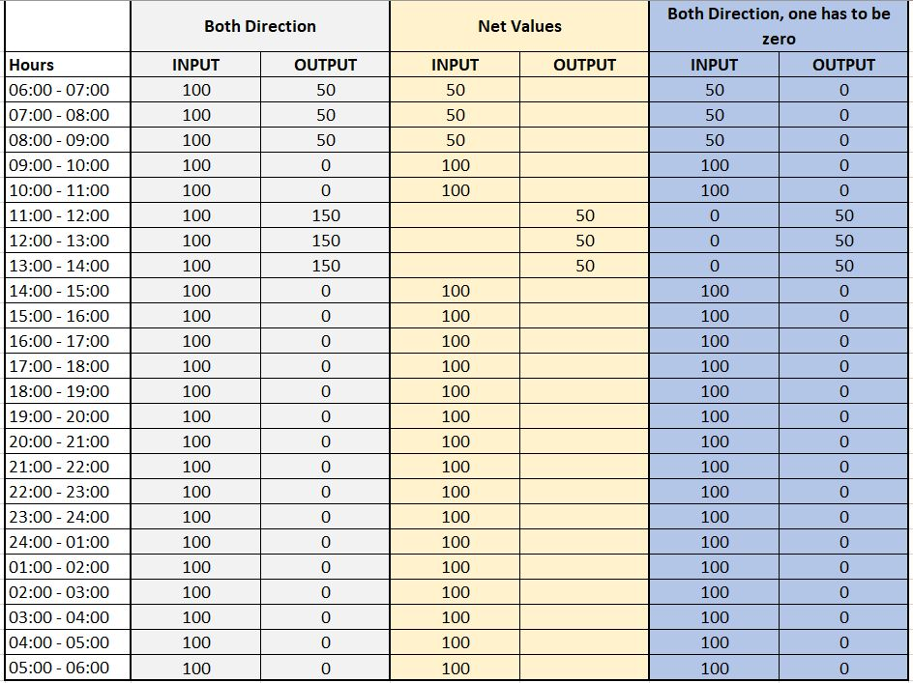

☐ We nominate “both direction”
☐ We nominate “net values”
☐ We nominate both directions where one has to be zero
☐ We nominate all types
Comments (optional) Click or tap here to enter text.
- How do you currently receive/send the confirmation (NOMRES) for nominations?
☐ Every hour (even if no changes are present)
☐ Following the receiving nomination
☐ Within 2 hours of the nomination deadline
☐ Other
Comments (optional) Click or tap here to enter text.

New version of Edig@s v6
- Do you prefer to send/receive nominations/confirmations including:
☐ Net values (only one direction per hour has to be submitted)
☐ Both directions (two directions per hour have to be submitted, one for each direction)
Comments (optional) Click or tap here to enter text.

- Would you like that historical data (past hours at within-day messages) is checked?
☐ Yes
☐ No
☐ No, since we don’t provide historical data
Comments (optional) Click or tap here to enter text.

- This questions is only relevant if question 12 was answered with yes: Should historical data (in the message) being checked against nominated or confirmed data?
☐ Confirmed data
☐ Nominated data
☐ Confirmed AND Nominated data
Comments (optional) Click or tap here to enter text.

- Should invoicing message be implemented within the Edig@s version 6?
If your answer is "yes" please indicate the processes you would like to have invoices for (e.g. capacity process, sales process) in the comment field below
☐ Yes
☐ No
Comments (optional) Click or tap here to enter text.

- How many connection point(s) / internal account(s) per NOMINT message would you like to have in version 6?
☐ Only one connection point and multiple internal accounts per message
☐ Multiple connection points and multiple internal accounts per message
☐ Only one connection point and one internal account per message
☐ Multiple connection points and one internal account per message
Comments (optional) Click or tap here to enter text.

- How many connection point(s) / internal account(s) per NOMRES message would you like to have in version 6?
☐ Only one connection point and multiple internal accounts per message
☐ Multiple connection points and multiple internal accounts per message
☐ Only one connection point and one internal account per message
☐ Multiple connection points and one internal account per message
Comments (optional) Click or tap here to enter text.

- What additional functionality / changes would you like to see in Edig@s v6?

