Public consultation on issues and impacts related to the CEN

gas quality standard EN16726:2015

Please respond by 15 July 2016

Introduction

ENTSOG has accepted the invitation to carry out an impact analysis and subsequently draft an amendment to the Network Code on interoperability and data exchange rules in conjunction with the CEN standard EN 16726.

EC foresees making the standard legally binding by including it in the network code and invites ENTSOG to prepare a detailed analysis –on the entire gas value chain in all relevant Member States- on the impacts and issues associated with codifying the standard and subsequently submit to ACER a proposal to amend the Network Code by 30 June 2017.

ENTSOG shares EC’s remark that a broad involvement of stakeholder is crucial to provide fundamental input to the analysis, especially on those issues outside the fields of expertise of our member transmission system operators.

ENTSOG invites stakeholders to contribute to the process from the earliest stage by answering to this public consultation. The results will be summarised by ENTSOG in the impact analysis, which will serve as the main supporting document for drafting the amendment.

The following principles should be considered, in view of ENTSOG, by stakeholders responding to this consultation:
- The standard EN 16726:2015 has been adopted by CEN and any revision of the gas quality parameters contained in that standard are outside the scope of this consultation.
- Wobbe Index discussion should be kept aside. The standard does not include any specification for Wobbe Index and, therefore, the impact analysis will not cover it. To this respect further standardisation work has been mandated to CEN by EC in pursue of an agreement on Wobbe Index. If this latter initiative is successful, the resulting revised standard will not become automatically binding. At that point in time, a second amendment process of the INT NC might take place.
- Think of the standard as a tool to remove barriers without creating new ones
- ENTSOG is open to consider any implementation option; nothing has already been decided.

As regards the methodology for this public consultation, the underlying principle is that an early proposal of policy issues and associated options shall be made to enable a proper impact analysis. Otherwise the lack of a clear legal framework would make it very difficult.
The questionnaire is divided in three different sections:
  - Section 1: general questions. This is a set of introductory questions on cross trade barriers related to gas quality and the approved CEN standard.
  - Section 2: scenario definition. This section describes the following policy issues identified by ENTSOG, which has been shared with stakeholders and is open to further suggestions:
    - Scope of application
    - Implementation timing
    - Interaction with existing mechanisms in the INT NC for removal of gas quality related barriers
    - Allowance for off-spec gas
    - A-deviations (conflicts with national legislation)
    - Application of flexible limits contained in the standard (CO₂, O₂)
For each of them, a number of possible options are proposed. The ones considered for the scope of application will be taken as starting point for the definition of four possible implementation scenarios. Stakeholders will be asked to select, for each scenario, the most coherent choices for the rest of policy issues.
  - Section 3: impact analysis of scenarios. Considering the scenarios presented in section 2, stakeholders will be asked to evaluate the positive and/or negative impacts providing fact-based evidence.

In addition to the answers, any complementary information can be sent to interoperability@entsog.eu from the same e-mail address as indicated in the contact details for this questionnaire.

Based on the answers received, ENTSOG will present in September 2016 an analysis of the 4 possible scenarios, including the related policy choices and the impact, and will base the amendment draft on the one that appears to be the optimum one.

Respondents to this public consultation are highly encouraged to:
- Support the answers to the questions with fact-based evidence
- As far as possible, liaise with the relevant European stakeholder organisation

The public consultation will be open until 15 July 2016.

Note: This is document is provided to facilitate the preparations of the questions. Actual answers shall be provided via the online survey on the ENTSOG website.

- Contact details
- Optional contact details
- Which EU Member State(s) do you represent?
  - List of EU Member States
  - Non-EU Member State (specify)
  - European interests (stakeholder association)
- Which segment (s) of the gas value chain do you represent? (multiple choice possible)
  - Production
  - LNG terminal operator
  - Storage operator
  - Transmission system operator
  - Distribution system operator
  - Industry
  - Power generation
  - Biomethane production
  - Domestic/commercial
  - Mobility
  - Other (explain)

- Please indicate in the text field provided whether you would like any part of the information provided to be kept confidential and be reported only in an aggregate manner :

Section 1: General questions
- Are you aware of any cross-border trade barrier related to gas quality at interconnection points or EU import points? What parameters are involved?
- Is there any segment, region or circumstance whose specific conditions don’t allow the application of the standard? Why? Is that related to any given parameter of the ones included in the standard?
- Is there any other policy issue you think should be considered in addition to the ones already identified?

Section 2: Scenario definition

Policy issue 1: Scope
- Scope of application of EN16726:2015: This European standard specifies gas quality characteristics, parameters and their limits, for gases classified as group H that are to be transmitted, injected into and from storages, distributed and utilised. This European standard does not cover gases conveyed on isolated networks.
- Scope of INT NC: This Regulation shall apply at interconnection points. But it also applies to transmission networks (Article 18) and to entry and exit points to third countries subject to NRAs’ decision.
- Scenarios considered:
  - Scenario 1: Whole chain: same scope as EN16726. That starts at entry points.
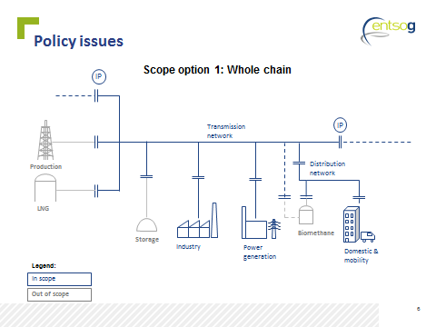

  - Scenario 2: Transmission networks.
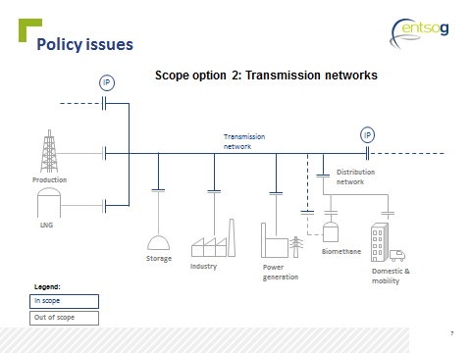

  - Scenario 3: At IPS: meaning connection points between two different TSOs and balancing zones.
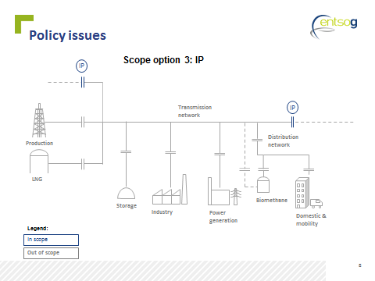

  - Scenario 4: National application on a voluntary basis (voluntary adoption).

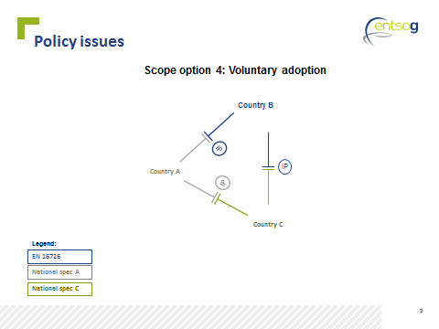

- Rank the scenarios in order of preference

Policy issue 2 Implementation timing
- It means the time required for the concerned parties to comply with the amendment to the Interoperability Network Code.
- Options considered:
  - Fixed and equal for all countries and segments
  - Flexible per segment of the chain
  - Flexible per regions
  - Flexible per segment and per regions
  - As decided by national authorities

- Regardless of your preference for a given scenario, what would be the most coherent choice in each case for policy issue 2? Why? (only one choice per row)
Implementation scenario | Fixed and equal for all countries and segments | Flexible per segments | Flexible Per regions | Flexible per segment and region | As decided by national authorities | Reasons (and detail on segment or proposed regions)
Whole chain
Transmission networks
Interconnection Points
Voluntary adoption

Policy issue 3: Interaction with INT NC
- The INT NC already provides mechanisms (Article 15) for the removal of gas quality related cross-border trade barriers that have been recognised by NRAs. In brief, the INT NC requires TSOs to carry out a joint cost benefit analysis and to submit a joint proposal to NRAs.
- How should this process interact with the application of the CEN standard?
- Options considered:
  - INT NC mechanisms don’t apply after transition period, except for parameters not covered in the standard.
  - INT NC mechanisms are applied as first option when a barrier is found. If no agreement is reached, the CEN standard will be applied.
  - INT NC mechanisms should be the only solution applied.

- Regardless of your preference for a given scenario, what would be the most coherent choice in each case for policy issue 3? Why? (only one choice per row)
Implementation scenario | INT NC mechanisms don’t apply after transition period, except for parameters not covered in the standard | INT NC mechanisms are applied as first option when a barrier is found. If no agreement is reached, the CEN standard will be applied | INT NC mechanisms should be the only solution applied | Reasons
Whole chain
Transmission networks
Interconnection Points
Voluntary adoption

Policy issue 4: Allowance for off-spec gas
- CEN standardisation work on gas quality was initiated in 2007 by Mandate M/400: “The Commission hereby requests CEN to draw up standards that define the minimum range to be accepted for gas quality parameters for H-gas. […] The goal is to define standards that are as wide as possible within reasonable costs”.
- A first aspect of this issue is whether TSOs (or DSOs for gas injected directly to distribution networks) can refuse to accept gas that is within the limits of the standard.
- Options considered:
  - Gas meeting the standard shall be accepted by infrastructure operators
  - Gas meeting the standard may be refused by infrastructure operators if national legislation sets stricter limits for the parameters contained in the standard

- Regardless of your preference for a given scenario, what would be the most coherent choice in each case for policy issue 4 ? Why? (only one choice per row)
Implementation scenario | Gas meeting the standard shall be accepted by infrastructure operators | Gas meeting the standard may be refused by infrastructure operators if national legislation sets stricter limits for the parameters contained in the standard | Reasons
Whole chain
Transmission networks
Interconnection Points
Voluntary adoption

- A second aspect is whether infrastructure operators can accept gas that is outside the standard
- Options considered:
  - Infrastructure operators can’t accept gas outside the standard
  - Infrastructure operators may agree less strict limits than those of the standard

- Regardless of your preference for a given scenario, what would be the most coherent choice in each case for policy issue 4 ? Why? (only one choice per row)
Implementation scenario | Infrastructure operators can’t accept gas outside the standard | Infrastructure operators may agree less strict limits than those of the standard | Reasons
Whole chain
Transmission networks
Interconnection Points
Voluntary adoption

Policy issue 5. A-deviations (conflicts with national legislation)
- A-Deviations inform on conflicts between national legislation and European standards.
- EN 16726 already includes A-deviations from several Member States. In addition, A-deviations can also be requested after publication.
- Adoption of standards is voluntary. When there is an EU harmonisation legislation enforcing the standard, it is not clear whether national legislations should be amended to eliminate A-deviations.
- Options considered:
  - A-deviations should be withdrawn after transition phase (implementation timing).
  - A-deviations should be retained unless otherwise decided by competent national authority.
Questions 14 to 18 are mainly addressed to stakeholders representing the interest of a given Member State
- Are there any national constraints caused by national legislation/ regulation?
- Are there stricter legal/regulatory requirements than given in EN 16726:2015 (A-Deviation)? For which parameters?
- Is an A-Deviation documented in EN 16726:2015?
- Are there less strict legal/regulatory requirements than given in EN 16726:2015 (no A-Deviation)? For which parameters?
- Are there any other legal/regulatory constraints? Please describe
- Regardless of your preference for a given scenario, what would be the most coherent choice in each case for policy issue 5? Why? (only one choice per row)

Implementation scenario | A-deviations should be withdrawn after transition phase (implementation timing) | A-deviations should be retained unless otherwise decided by competent authority | Reasons
Whole chain
Transmission networks
Interconnection Points
Voluntary adoption

Policy issue 6. Flexible limits
- For two parameters in the CEN standard (O2, CO2) there is a base limit with the potential for a higher limit up to a cap.
- Example (CO2): “At network entry points and interconnection points the mole fraction of carbon dioxide shall be no more than 2,5 %. However, where the gas can be demonstrated not to flow to installations sensitive to higher levels of carbon dioxide, e.g. underground storage systems, a higher limit of up to 4 % may be applied.”
- It is unclear who decides on flexible limits, how the decision is taken and for how long, what is the definition of a sensitive installation?
- Options considered:
  - Network operators and concerned parties carry out an impact assessment demonstrating the limit that could be applied with involvement of the relevant national authorities.

- What is your opinion on the proposed option?
- Do you suggest any other option?

General question:
- Please rank the policy issues in terms of difficulty

Section 3: Impact analysis of different scenarios

In terms of the impact of a possible whole chain implementation scenario for your segment, organisation or country please answer the following questions under the assumption that all national legislations deviating from the standard are withdrawn or amended and provide evidence supporting your statements:
- What benefits do you expect?
- What negative impacts might this scenario have?
- Are there any barriers to implement it?
- How much would it cost to overcome them?
- How long would it take?
- Do you foresee any risk in terms of security of supply?
- Do you foresee any impact in terms of price for your product(s)?
- Is this given scenario feasible for your segment/organisation/country?
- Could there be any unintended consequences?

In terms of the impact of a possible transmission networks implementation scenario for your segment, organisation or country please answer the following questions and provide evidence supporting your statements:
- What benefits do you expect?
- What negative impacts might this scenario have?
- Are there any barriers to implement it?
- How much would it cost to overcome them?
- How long would it take?
- Do you foresee any risk in terms of security of supply?
- Do you foresee any impact in terms of price for your product(s)?
- Is this given scenario feasible for your segment/organisation/country?
- Could there be any unintended consequences?

In terms of the impact of a possible implementation at interconnection points scenario for your segment, organisation or country please answer the following questions and provide evidence supporting your statements:
- What benefits do you expect?
- What negative impacts might this scenario have?
- Are there any barriers to implement it?
- How much would it cost to overcome them?
- How long would it take?
- Do you foresee any risk in terms of security of supply?
- Do you foresee any impact in terms of price for your product(s)?
- Is this given scenario feasible for your segment/organisation/country?
- Could there be any unintended consequences?

In terms of the impact of a possible voluntary adoption scenario for your segment, organisation or country please answer the following questions and provide evidence supporting your statements:
- What benefits do you expect?
- What negative impacts might this scenario have?
- Are there any barriers to implement it?
- How much would it cost to overcome them?
- How long would it take?
- Do you foresee any risk in terms of security of supply?
- Do you foresee any impact in terms of price for your product(s)?
- Is this given scenario feasible for your segment/organisation/country?
- Could there be any unintended consequences?

Last general question
- Is there any other option that should be considered?

Segment refers to different parts of the gas value chain: production, LNG terminals, transmission, distribution, storage, electricity generations, industrial consumption, domestic/commercial use, mobility, etc,

