**CAM Network Code**

**Second Auctions workshop**

**13.00 - 17.00**

26th October 2011

**3rd November 2011**

**Diamant Conference & Business Center**

**Bd A. Reyerslaan 80; 1030 Brussels**

**AUCTIONS WORKSHOP – BRIEFING NOTE FOR AUCTION GAMES**

**Introduction**

The aim of the auction game is to enable participants to understand the auction design options proposed in ENTSOG’s second CAM consultation on new or modified concepts. It is hoped that participants will get a feel for how the different auctions work through this interactive session.

The session will be composed of two interactive auction games. The first game will simulate a multiple round ascending clock auction for long term capacity. The second game will simulate a single round volume based auction with value discovery mechanisms for long term capacity. Auction rules for both auction designs will be based closely on those set out in the second formal consultation on new or modified CAM concepts. ENTSOG will present an explanation of the auction design for each particular game prior to the commencement of that game. Each game itself will last around 60 minutes depending on the auction results and the number of rounds that are necessary.

**Background and Assumptions**

This game is based on a simplified system involving three networks and two interconnection points (IPs), as shown below. Production occurs largely within Network A. Network B contains a large storage facility, while Network C has a high number of exit points to domestic and industrial customers. Bundled firm capacity is auctioned from A to B and from B to C.



Capacity at A🡪B and B🡪 C will be auctioned for a consecutive series of two years. For simplicity this game simulates an auction of yearly products; in reality the question of whether the longest product on sale should be yearly or quarterly remains open and is currently subject to consultation.

Participants will enter bids against price steps, which will be pre-set by ENTSOG and will differ between IPs and between years.

The game will be run using an Excel tool. Participants will enter bids into an Excel file within their individual teams and once the team have agreed the bids then the team leader will enter their agreed bids into a master excel file.

At the end of each round ENTSOG will aggregate the bids in the master excel file and display the bidding information, including the clearing price.

**Multiple round ascending clock auctions**

In this type of auction bidders bid against price steps which are called out successively, at regular intervals, starting with P0. This is known as an ascending clock approach. Capacity is allocated once demand at a certain price step is equal to or lower than the capacity on offer. This approach means that network users would always have the chance to actively decide whether to place a bid at a higher price or not.

**Single round volume based auctions with value discovery mechanisms**

In this type of auction there is one bidding round with a defined number of price steps. Bidders bid volumes against a series of prices over a period that may last up to 10 ‘days’ (each day will be represented by a period of around 5 minutes in the game). After each day, information on bids submitted is published to aid price discovery. There are also additional mechanisms to encourage price discovery. There are three mechanisms, known as stability measures, which are:

(1) immediate closure (auction closes after Day 1 if clearing price is the reserve price, P0)

(2) early closure of bidding window (auction closes after any day if the clearing price has not changed due to bid revision since the end of the previous day)

(3) limitation of bid revision (bids at the reserve price are binding; bids at other price steps may be revised upwards providing demand curve is decreasing but may not be revised downwards).

**Simplifying assumptions**

An actual auction of long term capacity, as included in the second CAM consultation document, will involve concurrent auctions of either annual or quarterly products covering a period of 15 years, across c.150 IPs with potentially unlimited price steps.

This situation implies a very high number of bids per user and would be far too complex for the game. We have therefore simplified as follows:

* 2 years
* 2 IPs
* 15 price steps
  + – 3 discrete price steps are announced in each round in the multiple round game

In addition, in this game bidders must accept whatever capacity they are allocated, up to and including the quantity they bid. There will be no minimum bids.

**Scenarios**

Participants will be split into groups of around 5. Each group will have at least one ENTSOG facilitator to ensure the group understands the game, to promote discussion, and to answer questions on the game itself and on auctions more generally.

Each group will be provided with an envelope containing a business scenario that will influence the amount of capacity they will try and purchase at each IP and for each year.

**Appendix 1**

**Additional Information:**

The following information is taken from Section E (Auction Algorithms) of the ‘Second Formal Consultation on New or Modified Concepts’ as part of the overall Capacity Allocation Mechanism (CAM) Network Code process.

**E.1 Overall methodology**

**Introduction**

In the draft CAM NC ENTSOG proposed a single round auction in which unconstrained adjustment of bids was possible throughout the bidding window and interim information was published. However ENTSOG noted that under such a model, additional measures might be necessary in order to incentivise early bidding and allow full value discovery.

The supporting document noted that a number of alternative models were also possible, including a multiple-round model such as an ascending clock approach.

Both single and multiple round options gained support from respondents to the last consultation and both models have been subject to discussion and refinement within ENTSOG. While ENTSOG Members have expressed a preference for one of the two models, full reasoning that would favour one model over the other has not yet been developed. Therefore, both options are set out below for further debate.

The algorithm included in the final CAM NC will not ensure the outcome of one cross-border auction is linked to the outcome of an upstream or downstream auction. Given the combinatorial nature of this problem, the algorithm to solve it would either require discriminatory prioritisation between all possible options, or be unfeasibly complex.

Under both options, the level of the price steps would be announced in advance of the auction.

The options described below would apply to longer duration auctions: quarterly, annual monthly and rolling monthly auctions under Option 1 in section D.1, yearly, annual quarterly and rolling monthly auctions under Option 2 in section D.1. For day-ahead and within-day products, the simpler uniform price algorithm applied to these durations in the draft CAM NC was supported by the market, and no change is proposed.

**Options**

**Option 1: Multiple round ascending clock model**

Under this model, rather than users bidding simultaneously against a series of price steps at once, discrete price steps would be announced successively, at regular time intervals, starting with P0 (an ascending clock approach). Capacity would be allocated for each standard capacity product on offer once demand at a certain price step is equal to or lower than the capacity on offer in that specific auction. This approach would mean that network users would always have the chance to actively decide whether to place a bid at a higher price or not. The conditions for a valid bid in a subsequent round is that the new quantity is lower or equal to the previous one, implying that participants must be present from the first round and that demand curve progressively submitted is a decreasing curve.

This option incorporates an “automatic bidding assistant” which allows bidders to specify their bids at each price step in advance of the auction, if they wish. Bidders therefore have the option of monitoring the auction process and actively deciding whether and how much to bid at each price step, or (as with the single round option below) to submit all bids at the start of the process with no further involvement in the process required.

*Figure 3: Illustration of multiple round ascending clock model with automatic bidding assistant*

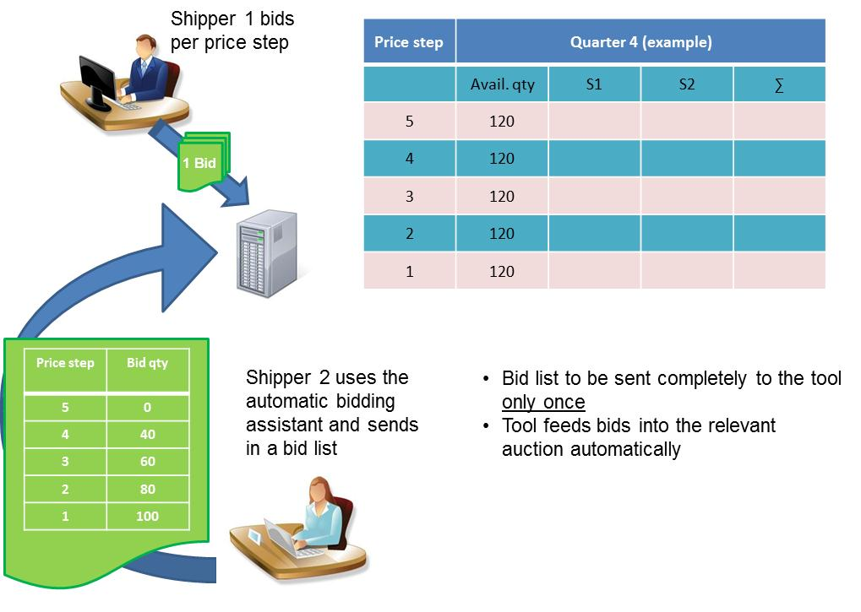

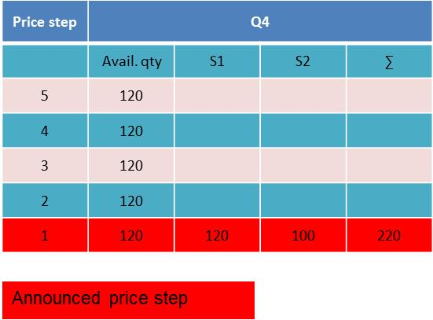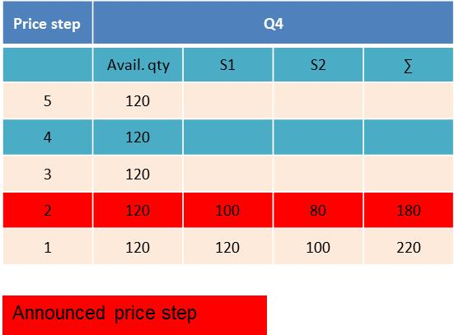

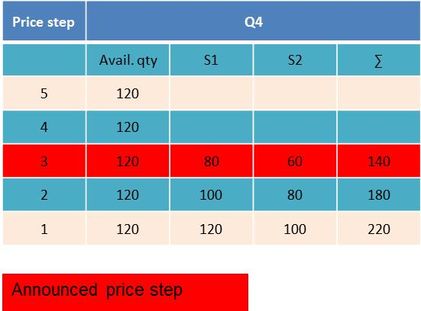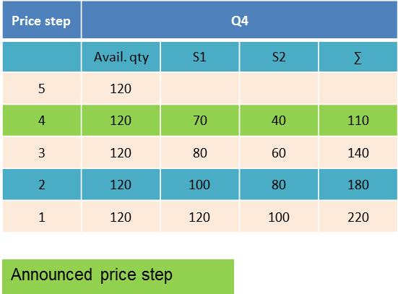

In the above example the auction clears at P4.

**Option 2: Single round volume based model with value discovery mechanisms**

This option is similar to the solution proposed in the draft CAM NC and supporting document. In summary:

* + - One bidding round with defined price steps, which may last several days
    - Bidders bid volumes against announced prices
    - Auction has pre-defined “latest end date”
    - Publication of aggregated demand within the round (price discovery)

*Figure 4: Illustration of single round volume based model*

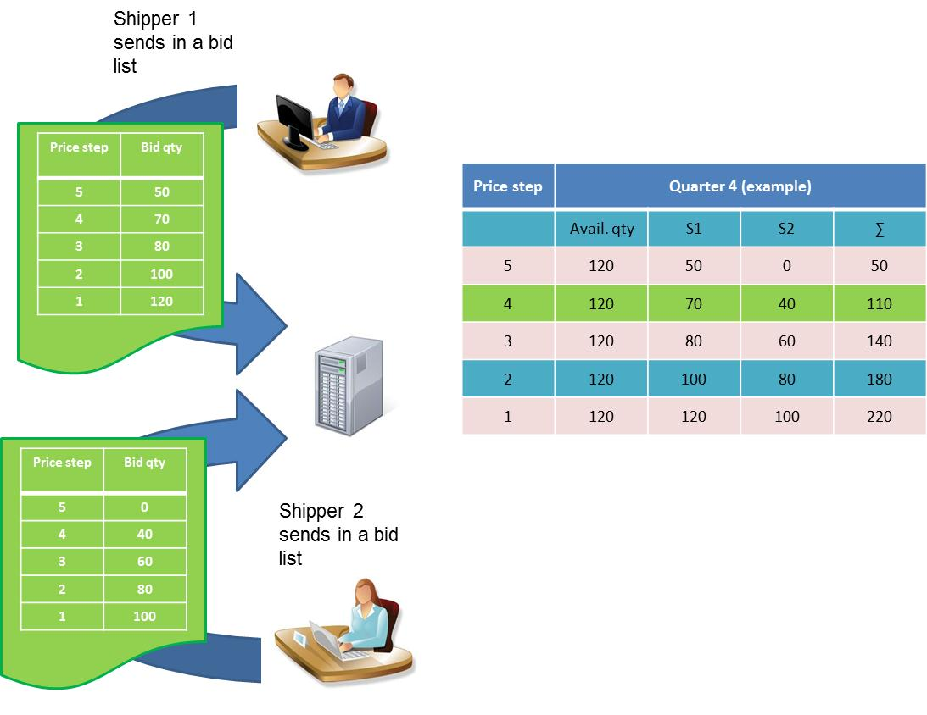

Unlike the draft CAM NC solution, however, this option includes additional measures to support price discovery (requested by majority of consultation respondents if ENTSOG adopts a single round approach). This message was reiterated by participants at the ENTSOG Auctions workshop on 20 July 2011. Following input from consultation respondents ENTSOG has developed some measures to promote stability. These are described below.

In the explanations below, Di represents a particular day of the bidding window; CP is clearing price; Px represents a particular price step; Q is the quantity bid at a particular price step and on a particular day.

* Option 2 additional measure A: **Early Closure of Bidding Window**, in order to stimulate early value discovery.

Early closure measures apply when stability in demand is reached or if demand is lower or equal to the offer.

Proposal:

* “immediate closure rule”: bidding window closes after D1 if CPD1 = P0. Please note that this closure rule also applies if no bids are entered during Day 1.

In addition:

* “early closure rule”: bidding window closes early, if the clearing price does not change due to bid revision(s) between the end of one day during the bidding window and the end of the next.

Under this proposal, these measures would apply independently to each standard capacity product on sale. ENTSOG welcomes views on this, and particularly on whether it would be compatible with any potential future mechanism for the allocation of incremental capacity.

* Option 2 additional measure B: **Limitation of bid revision.**

Similarly to ascending-clock the demand curve remains a decreasing function, with upper level defined on D1 for the lowest price possible, but eventual extension over prices. Bidders can increase their bids at a price step (except P0) to try and gain the capacity they want, but cannot reduce them. Bids at the reserve price are binding. In mathematical terms,

for all Px, except P0, where 

The restriction implied by this formula is illustrated below:

*Figure 5: Limitation of bid revision*

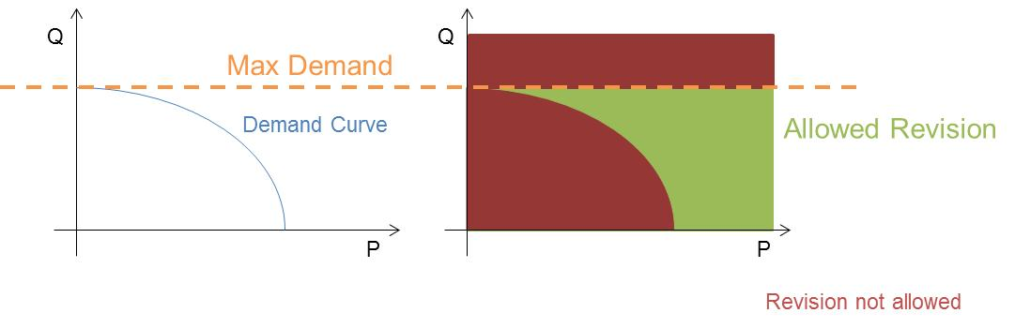

The bid standing at the time of closure of the bidding window on each day is the relevant bid for this assessment.

ENTSOG notes that a single round auction model could apply some, all or none of these stability measures. Please indicate which, if any, of these measures you would like to be included.